**Survey on AI Driven Agribot**

**1Vaibhav Nrupnarayan 2Harish Bagul 3Abhiman Bade 4Dr.Kavita Joshi**

1,2,3Student 4Faculty

1,2,3,4Department of Electronics and Telecommunication Engineering

G.H. Raisoni College of Engineering and Management, Pune, India.

1. **Abstract**

The AI-driven Agribot project presents an innovative solution to modernize rice farming by integrating Machine Learning (ML) and Internet of Things (IoT) technologies to automate rice planting and crop quality check. Traditional rice cultivation is labor-intensive, time-consuming, and prone to inefficiencies, resulting in higher costs, inconsistent planting, and reduced yields. The Agribot is designed to address these challenges by precisely planting rice seedlings, and evaluating crop health using image processing techniques. By collecting the plantation data and plant conditions through camera, the system enables data-driven decision-making about the crop health (Plant is healthy or unhealthy) to improve crop quality, and enhance yields.

AI-driven algorithms allow the Agribot to make intelligent decisions, such as detecting plant health and thereby improving overall farm management. The system reduces reliance on manual labor, increases planting accuracy, and enhances productivity, making farming more efficient and profitable. This project holds the potential to transform agricultural practices by fostering precision farming techniques, ultimately contributing to better food quality and sustainable agricultural development. By modernizing rice farming, the AI-driven Agribot can lead to significant advancements in crop production, benefiting both farmers and the agricultural industry.

1. **Introduction**

Agriculture is a cornerstone of many economies as in India, especially in regions where rice serves as a staple crop. Traditional methods of rice cultivation, are labor-intensive, time-consuming, and often inefficient, leading to increased costs and inconsistent yields. In response to these challenges, the AI-Driven Agribot project aims to revolutionize rice farming by automating the planting process of the rice seedling and enhancing the quality analysis of crops through advanced technologies.

The Agribot leverages Machine Learning (ML) and Internet of Things (IoT) technologies to create a smart, automated system capable of precise rice planting and real-time plantation monitoring. Using image processing techniques, the Agribot can evaluate plant quality and that the farmer can take informed decisions to optimize crop production. Additionally, sensors continuously monitor key factors such as plantation done and loaded plants on the loader, enabling farmers to manage their crops more effectively and efficiently.

By reducing reliance on manual labor, improving planting accuracy, and providing detailed data for decision-making, this project seeks to enhance agricultural productivity, reduce costs, and ensure sustainable farming practices. The AI-Driven Agribot represents a significant step towards modernizing agriculture, utilizing technology to increase food security and promote more efficient farming methods.

1. **Literature Survey**

One study discusses the development of a robot tractor equipped with technologies like RTK, GPS, and IMS for precise navigation, which not only turns the soil but also functions as a rice planter. This system uses the Can Bus protocol for real-time communication, improving efficiency and allowing the robot to work autonomously in the field.

Another approach utilizes a crank-slider mechanism for continuous seeding, achieving a high accuracy rate of 92% and reducing the time required for manual labor. The four-wheel design ensures ease of movement, while the robot's battery life of up to four hours enhances its operational efficiency.

Cloud-based data management is another aspect explored in the literature. Sensors connected to microcontrollers upload data to the cloud, allowing for real-time analysis and monitoring of crop health. This enables farmers to make informed decisions about crop management, enhancing productivity.

The use of AI in agriculture has also been a focus, particularly for detecting plant diseases and quality assessment. Techniques like image processing and neural networks have been applied to identify crops, evaluate quality, and detect diseases based on texture and colour features. For instance, using CIELAB colour models and Artificial Neural Networks (ANNs), systems can classify and identify unhealthy regions of plant leaves, enhancing precision in disease detection.

Navigation algorithms, crucial for autonomous agricultural systems, are also highlighted. Capacitive touch sensors and azimuth sensors guide robots in complex environments such as uneven fields or terraced paddies, ensuring accurate planting even in challenging conditions.

These studies provide foundational insights that drive the development of the AI-Driven Agribot, emphasizing the integration of robotics, Machine Learning and IoT to revolutionize rice farming by automating labour-intensive processes and enhancing crop quality control.

1. **Problem Identification**

The problem of rice cultivation is multifaceted, particularly due to its labor-intensive nature and challenging environmental conditions. Traditional rice planting methods require significant manual effort, often leading to inconsistent planting, increased labor costs, and inefficient use of resources. Moreover, farmers face dangers from hazardous insects and snakes commonly found in rice fields, further complicating labor availability. This results in increased operational costs and reduced overall efficiency in farming practices.

Another critical issue is the inconsistent quality control of rice crops, which negatively impacts market value and consumer trust. Ensuring consistent, high-quality rice production is difficult without advanced quality monitoring and management systems. Addressing these problems requires an innovative approach that reduces reliance on manual labor, improves planting precision, and enhances crop quality through real-time monitoring and intelligent decision-making. The AI-Driven Agribot aims to resolve these challenges by automating the rice planting process, integrating ML-based quality control measures, and ensuring safer and more efficient agricultural practice.

1. **Proposed Work**

AI-Driven Agribot that automates rice planting and enhances crop quality monitoring using Machine Learning (ML) and Internet of Things technologies. The system is designed to address key challenges in traditional rice farming, such as labor-intensive operations, inconsistent planting quality, and high operational costs.

The Agribot will be equipped with a rice planting mechanism that uses a robotic arm driven by a slider crank mechanism, ensuring precise placement of seedlings in the field. A Raspberry Pi will serve as the central controller, managing the robotic arm, motor control, and sensor data processing. The sensors will continuously monitor parameters like providing real-time data to optimize plantation process and Planting management.

In addition, the system incorporates an AI-driven image processing module that will analyze the quality of rice plants. By capturing images of the crop, the system will segment, classify, and evaluate the plants to identify potential issues such as disease, weed presence, or other defects. The AI model will be trained to distinguish between healthy and unhealthy crops, allowing the Agribot to take corrective actions, such as initiating timely fertilizer application before critical damage occurs.

The proposed system aims to improve planting accuracy, reduce dependency on labor, and enhance crop quality control, ultimately leading to increased productivity, cost reduction, and a more efficient rice farming process.

1. **Methodology**

The methodology for the AI-Driven Agribot project follows a structured approach to developing an autonomous rice planting system by integrating hardware, software, and advanced Machine Learning and IoT technologies. The process begins with system design, where the overall architecture is conceptualized, focusing on mobility, planting precision, and monitoring of plant health. The mechanical structure, including the drive mechanism and a robotic arm with a slider-crank mechanism for precise seedling planting, is laid out. Key hardware components such as DC motors, motor controllers, and sensors are assembled, with a Raspberry Pi acting as the central control unit. Image processing is handled through a camera system, enabling health monitoring of crops.

On the software side, control algorithms are developed for motor coordination and sensor data acquisition, with machine learning algorithms implemented for image processing and plant health detection. The software also provides a dashboard for real-time monitoring of environmental conditions and alerts for any issues. Data collection from sensors allows the system to continuously monitor parameters like soil moisture and temperature, with AI-driven analysis predicting potential issues and suggesting timely interventions, such as fertilization.

The testing phase includes both controlled and field tests to fine-tune the hardware and software and assess the system’s performance in real-world farming conditions. Comprehensive documentation is maintained throughout the development process, ensuring that the system’s design, testing, and results are well-recorded. This methodology integrates advanced technology with practical agricultural needs, optimizing rice farming through automation and AI-driven insights.

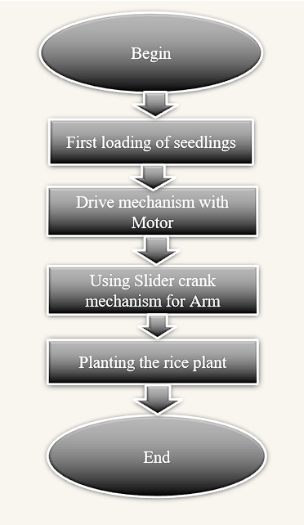

**Process of Planting**

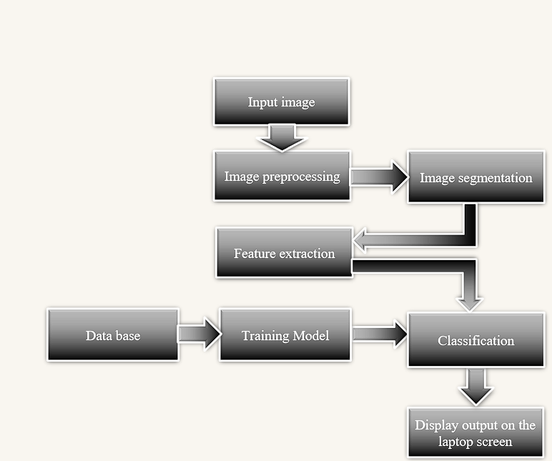

**Process of Health Detection**

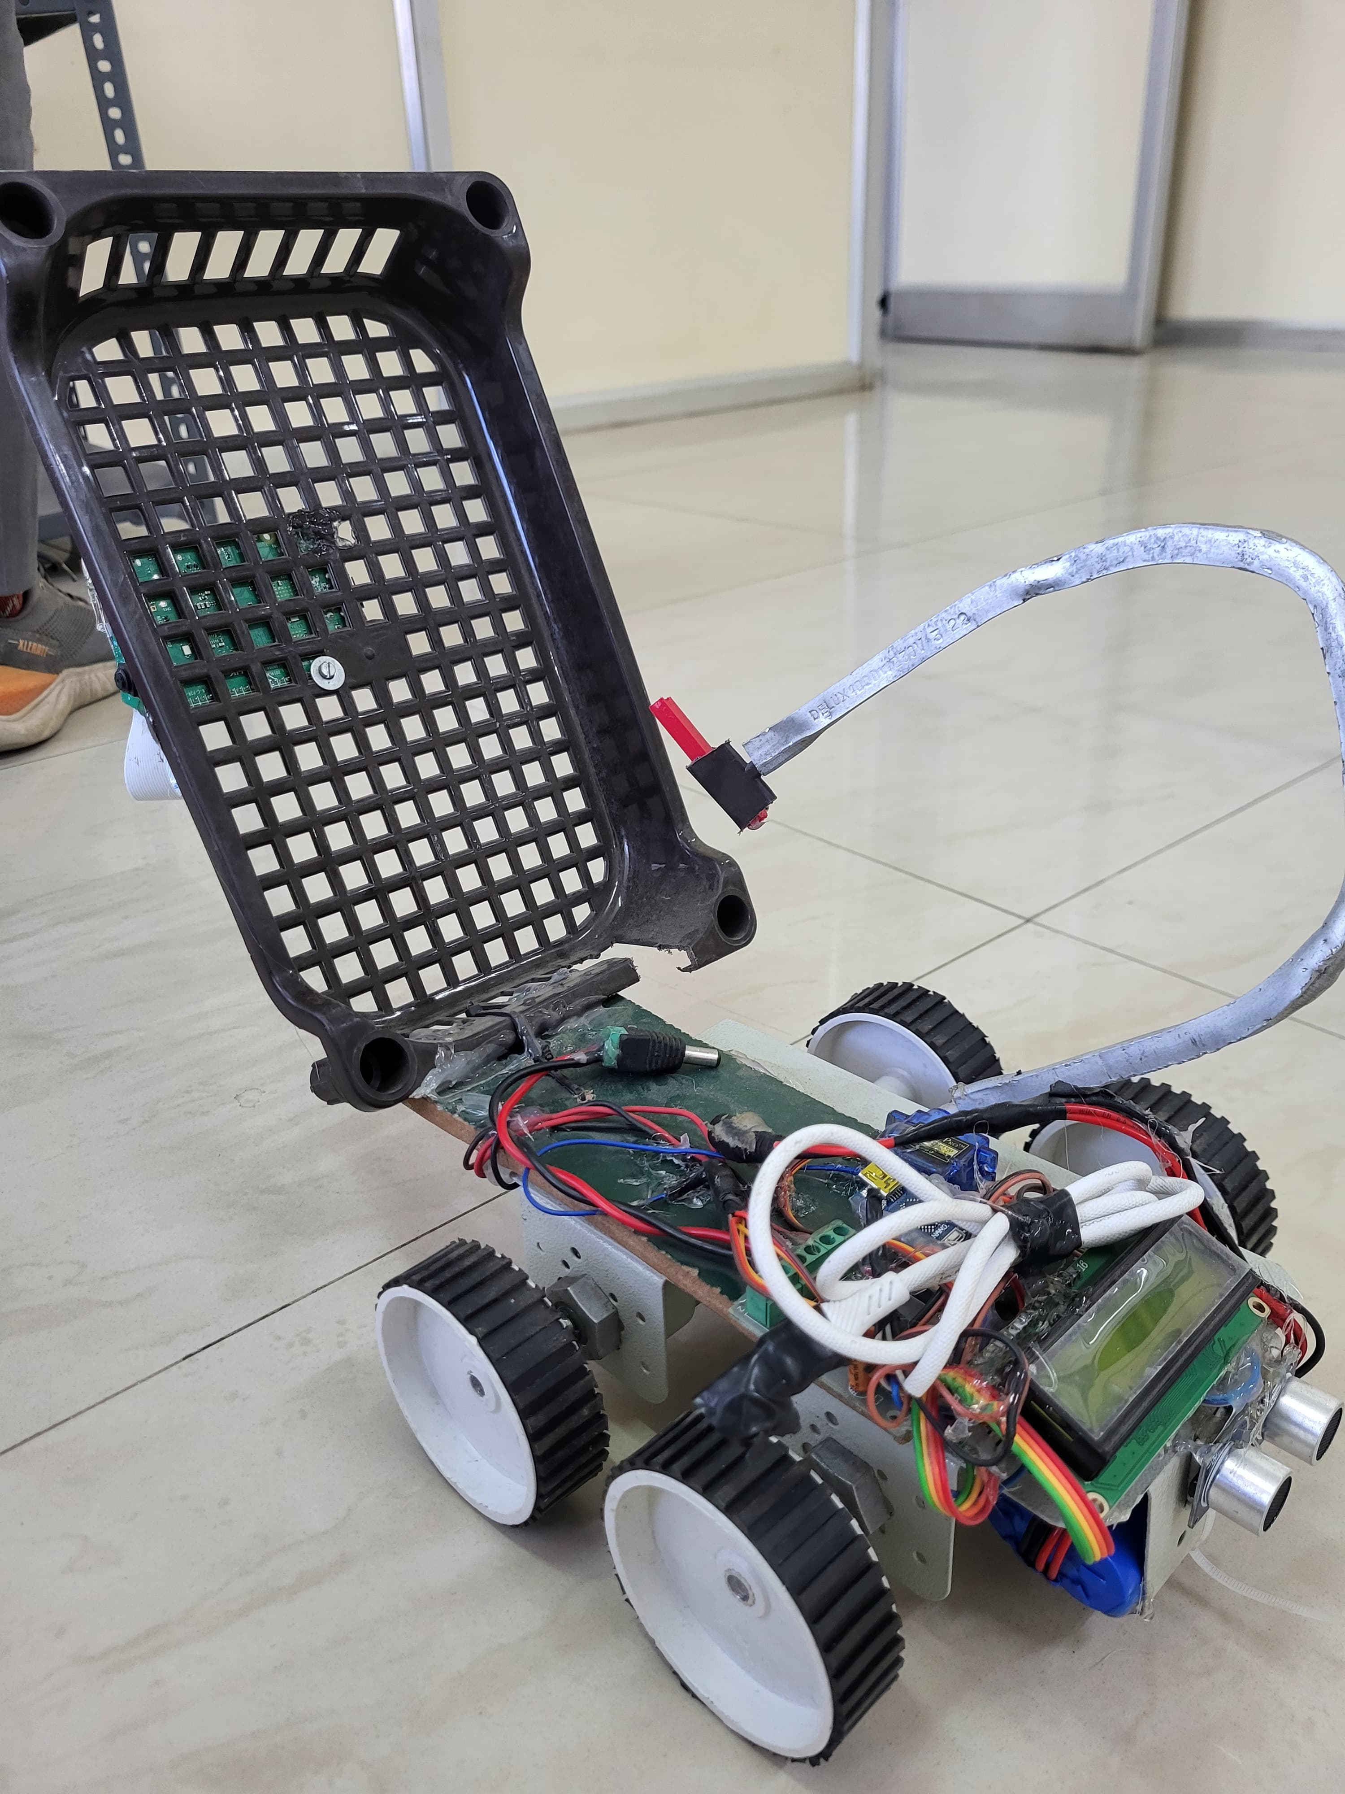

**Rice Plantation Prototype**

1. **Conclusion**

AI Driven Agribot aims to revolutionize rice farming by integrating AI technology with data monitoring to optimize enhance crop quality, and promote sustainable practices. By addressing the inefficiencies and challenges in traditional rice farming, Agribot seeks to improve yields and achieve high-quality production while ensuring environmental stewardship.

1. **Acknowledgement**

We would like to express our deepest gratitude to Dr. Kavita Joshi, our esteemed guide, for her invaluable guidance, support, and encouragement throughout the development of this project. Her expertise and insights have been instrumental in shaping our work and helping us achieve our goals.

We are also immensely thankful to the Department of Electronics and Telecommunication Engineering, G.H. Raisoni College of Engineering and Management, Pune, for providing us with the necessary resources and infrastructure to carry out this project. Special thanks to Dr. Sandeep Hanwate, Project Coordinator, and Dr. S.K. Waghmare, Head of Department, for their continued support and for fostering an environment conducive to innovation and learning.

Finally, we extend our heartfelt appreciation to our teammates and colleagues for their unwavering support and encouragement throughout the duration of this project. Without their help and understanding, the successful completion of this work would not have been possible.

1. **References**

[1] Hitoshi Sori, Hiroyuki Inoue, Hiroyuki Hatta, and Yasuhiro Ando. ‘‘Effect for a Paddy Weeding Robot in Wet Rice Culture’’. Japan. February 27, 2018.

[2] Elsayed Said Mohamed, Sameh Kotb Abd-Elmabod, Mohammed A El-Shirbeny, Mohamed B Zahran. ‘‘Smart farming for improving agricultural management’’. Egypt, 2019.

[3] Prabira Kumar Sethya, Nalini Kanta Barpandaa, Amiya Kumar Rathod, Santi Kumari. “Image Processing Techniques for Diagnosing Rice Plant Disease”. India.

[4] Muhammad Junaid Asif, Tayyab Shahbaz, Dr. Syed Tahir Hussain Rizvi, Sajid Iqbal. “Rice Grain Identification and Quality Analysis using Image Processing based on Principal Component Analysis”, Pakistan, 2018.

[5] Pramod Kumar Sahoo, Dilip Kumar Kushwaha, Nrusingh Charan Pradhan, Yash Makwana, Mohit Kumar, Mahendra Jatoliya, Arjun Naik, Indra Mani, “ROBOTICS APPLICATION IN AGRICULTURE”, India,2022.

[7] Mohd Saiful Azimi Mahmud, Mohamad Shukri Zainal Abidin, Abioye Abiodun Emmanuel and Hameedah Sahib Hasan, “Robotics and Automation in Agriculture: Present and Future Applications”,Malaysia, April 2020.

[8] Vijai Singh Asst Professor, Varsha Asst Professsor, Prof. A K Misra, “Detection of unhealthy region of plant leaves using Image Processing and Genetic Algorithm”, India, 2015.

[9] K. Tamaki, Y. Nagasaka, K. Nishiwaki, M. Saito, Y. Kikuchi, K. Motobayashi, “A Robot System for Paddy Field Farming in Japan”, Japan, 2013.